**SCENARIO 1**

Javascript commands:

conn = new Mongo("localhost:27017");

db = conn.getDB("College1");

scenario1Coll = db.getCollection("OneToFew");

// students

ivona = {

    uid: 123456789,

    firstName: "Ivona",

    lastName: "Bok",

    year: 3

}

ivan = {

    uid: 234567890,

    firstName: "Ivan",

    lastName: "Smith",

    year: 4

}

sally = {

    uid: 345678901,

    firstName: "Sally",

    lastName: "Struthers",

    year: 3

}

// sections

doc = {

    sectionID: "ISTE12301",

    title: "My Database Course",

    creditHours: 3,

    room: "GOL-2650",

    students: [ivona, ivan]

}

scenario1Coll.insertOne(doc)

doc = {

    sectionID: "ISTE23401",

    title: "My Other Database Course",

    creditHours: 4,

    room: "GOL-2620",

    students: [ivan, sally]

}

scenario1Coll.insertOne(doc)

Results:

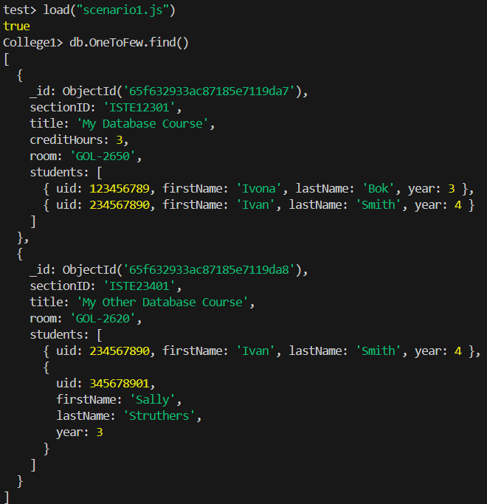

**SCENARIO 2**

Javascript commands:

conn = new Mongo("localhost:27017");

db = conn.getDB("College2");

sections = db.getCollection("Sections");

students = db.getCollection("Students")

// sections

iste12301 = new ObjectId()

doc = {

    _id: iste12301,

    sectionID: "ISTE12301",

    title: "My Database Course",

    creditHours: 3,

    room: "GOL-2650"

}

sections.insertOne(doc)

iste23401 = new ObjectId()

doc = {

    _id: iste23401,

    sectionID: "ISTE23401",

    title: "My Other Database Course",

    creditHours: 4,

    room: "GOL-2620"

}

sections.insertOne(doc)

// students

doc = {

    uid: 123456789,

    firstName: "Ivona",

    lastName: "Bok",

    year: 3,

    mySections: iste12301

}

students.insertOne(doc)

doc = {

    uid: 234567890,

    firstName: "Ivan",

    lastName: "Smith",

    year: 4,

    mySections: [iste12301, iste23401]

}

students.insertOne(doc)

doc = {

    uid: 345678901,

    firstName: "Sally",

    lastName: "Struthers",

    year: 3,

    mySections: iste23401

}

students.insertOne(doc)

Results:

